Questions de cours :
- A least-square formulation may be used to built-up a model representing data = True
- A least-square formulation may be used to built-up a model fitting data at best = True
- The VDA method can be viewed as a non-linear least-square method but with an underlying model = True
- The VDA method can be viewed as a non-linear least-square method but with an underlying model with the model as an equality constraint = True

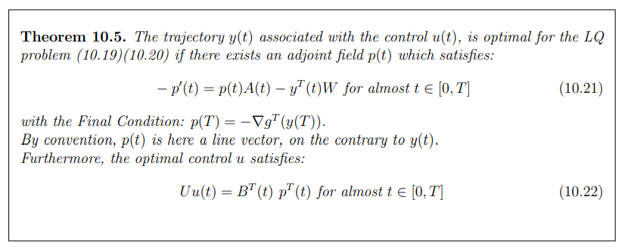

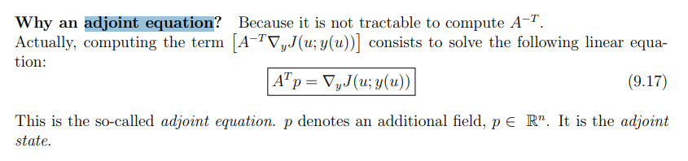

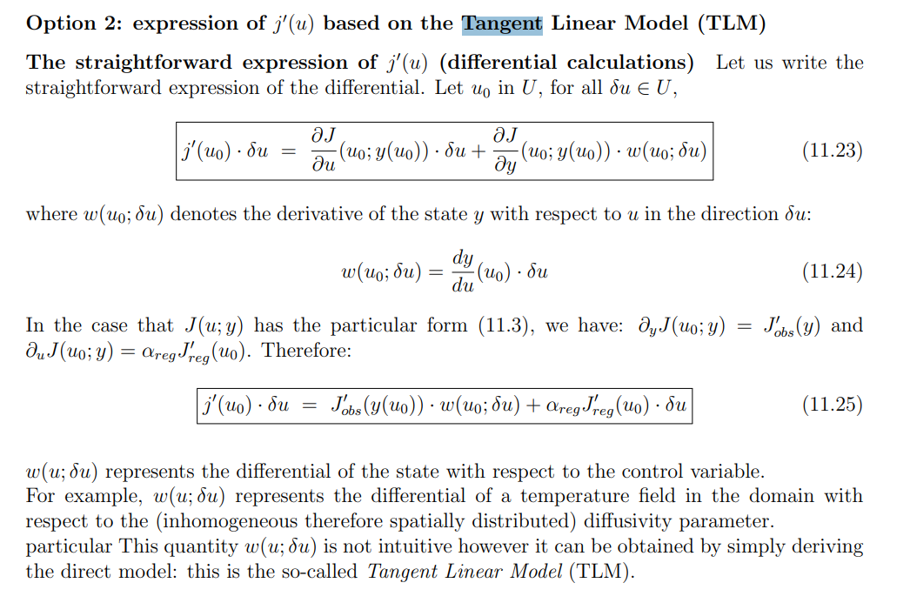

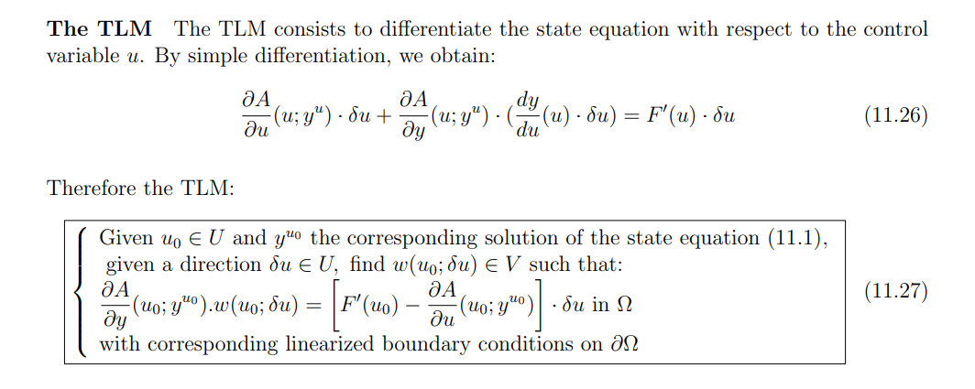

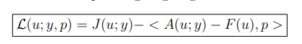

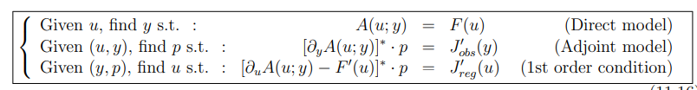



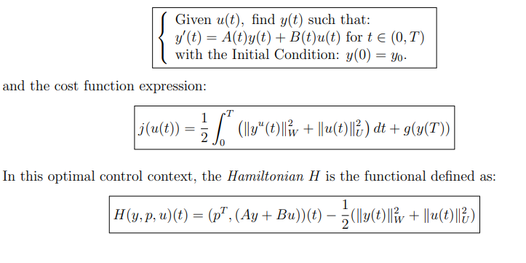
The Hamiltonian:
